## Source Material

This game, *Oedipus - The Threads of Fate*, derives from a masterpiece of tragedy, *Oedipus Tyrannus* by Sophocles, and explores the wonderful mythology of the ancient Greeks. Both *The Odyssey* and *The Iliad* take major roles in the story.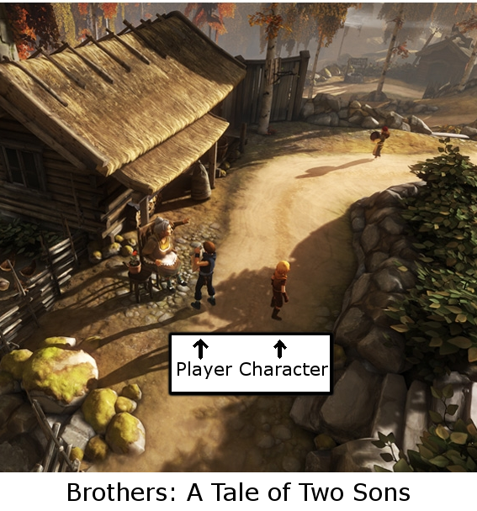

## Introduction

**Title**: *Oedipus - The Threads of Fate*

**Genre**: Adventure

**Player Perspective**: Third Person, in the style of *Brothers* →

**Style**: Linear, with open areas

**Rating**: T

*Oedipus - The Threads of Fate* is an adventure game set in the mythology of Ancient Greece. The linear structure of the game is built by a series of open areas where exploration is necessary and where puzzles are encountered. The game is expected to be rated T, as it deals with mature themes and includes violence.

## Story Overview

You were a king: a ruler of men. But even kings must serve the gods. And even the gods must serve the Moirai: 3 Goddesses who determine the destinies of all, weaving the threads of fate into the fabric of time.

The fate they gave you was nothing short of unholy. You were given up at birth, so how were you to know that the man you killed was your father, and your new wife your own mother. You were cast from your throne and blinded by your own hands, but you saw the truth: there was nothing you could have done differently. And yet you obsessed over this fate, for it stole your children from you, your mother and father, and the innocent lives of countless others. You have lived in solitude for 20 years, hidden away from those your fate brought pain to, dwelling on your past. Until the Ruler of the Underworld brought you a proposition.

Hades was sick of being stuck in hell. Overlord of the damned. None wished to be near him, even his name struck terror in their hearts. His siblings on Mount Olympus were praised and constantly given sacrifices, but not Hades. He wished to gain a seat with them, but when he asked for one, they laughed in his face. So he traveled through time, making his mark on the stories of old so that he would not be loathed but loved by the Greeks and the Gods. However, time is a tricky thing, and try as he might, Hades was unable to control the ramifications he had on the timeline. The 12 Olympians noticed his irreverent actions, and he is now on trial for his behavior. So the God of the Underworld has asked you to travel through time, from thread to thread, myth to myth, fixing his mistakes. In return, he says, you will be able to meet the Moirai at the very beginning, and change your fate.

You accept.

Throughout your journey through time, you become more like your young self. Hope fills your heart, and the strength of youth revitalizes you. As you solve puzzles fixing the timeline, you engage in combat with increasing fervor. Your fate haunts you as you try to reverse it, with your past demons disguising themselves as your enemies. In turn you resort to anger, a cruel rage that burns inside your body and lashes out at these apparitions. But as long as you have your fate in mind, you are sure you will be able to affect it.

## Characters

**Oedipus**

**Role:** Protagonist, Player Character

Oedipus was a good ruler, but he was an arrogant man and quick to anger. He unknowingly killed his own father and married his own mother. For these crimes against the gods, his city suffered, his tyranny faltered, and his eyes wept blood. Oedipus has lived in solitude for 20 years, dwelling on the inevitability of his fate, replacing the traits of anger and arrogance with thoughtful philosophy. Given the chance to change his past, he accepts, and begins an ultimately self-destructive journey where he regains the characteristics of his younger self. His limp, an injury he received as an infant that is representative of how his past never leaves him. His blindness causes him to rely on memories for his perception, deluding him in moments of intensity when he sees threats as enemies from his past.

Oedipus needs to realise there is more to life than his past, and that he simply cannot change fate. He fails in this, instead becoming the very cause of his despised fate.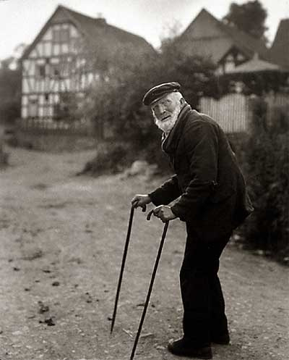

**Hades**

**Role:** Antagonist

Hades is reviled for what he represents, death, and he wanted to change that. After the 12 Olympians revoked his request for a seat on Mount Olympus, he invented a mechanical steed programmed to traverse time, and going back, changed the great myths of *The Odyssey* and *The Iliad* so that they would give him a better image. He was unable to get the changes to give him a better image, but the other Gods noticed the timeline was being changed, and putting two and two together, ordered him to be tried for disrupting time. In a last ditch effort, he asked Oedipus to travel back and undo his changes, thereby erasing any evidence of his involvement. He however, set Oedipus up for failure in his quest to change his fate, ensuring that Oedipus would be culpable for any changes to the timeline. Hades is very intelligent and duplicitous, but he struggles with low self esteem, focusing on how others perceive him.



**The Moirai**

**Role:** Ancillary, false-antagonist

The Moirai are the three Goddesses who have decided the fates of all in existence. They weave the threads of fate into the fabric of time, which they designed at the very beginning. They have perfect knowledge, and total power, but they were given their role at the beginning of time and have no choice but to continue. They take their job very seriously. At the end of the game, the very beginning of time, Oedipus confronts the three sisters, requesting his fate to be changed. When they do not accept Oedipus’s request, Oedipus lashes out in fiery rage, striking the sister in her eye, giving her the scar that the player will have seen throughout the game.

**Telemachus**

**Role:** Ancillary

Telemachus is the son of Odysseus in *The Odyssey*, and the first character Oedipus meets upon traveling through time. Telemachus is an angsty teenager in search of meaning. His life is being ruined by the suitors who dwell at his father’s house. He is young and strong, but he does not know his full potential. He is lost in his search for meaning in life: without a father to raise him, he doesn’t know who he is. Telemachus wants to be shown how to go about life, but he needs to realize he just has to be himself.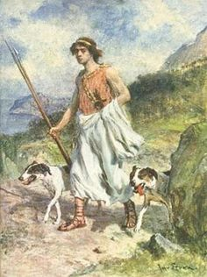

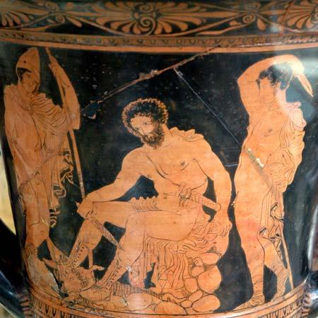

## Gameplay

**Story Conflict**: Oedipus must fix the storylines, overcoming the obstacles in his way to reach the Moirai.

**Game Conflict**: The player must solve puzzles and defeat the enemies in their way to win.

By solving puzzles, you fix the storylines, and experience the story within them. Through combat Oedipus becomes progressively more violent. The story conflict gives a bigger scope to the game conflict.

**Levels**

1. Oedipus’s home in the woods
2. Ithaca (The Odyssey 1)
3. Mycenae (The Iliad 1)
4. Ithaca - Odysseus’s return (The Odyssey 2)
5. Troy (The Iliad 2)
6. Oedipus on the mountain (Oedipus Tyrannus)
7. The beginning of time / The Moirai

**Controls**

With the left stick, Oedipus’s movement is controlled. With the right stick you control the orientation of the camera. Right trigger allows you to interact with the world, entering dialogue with another character, picking up some item, or using something in the environment.

Upon entering combat, the left joysticks mapping shifts from controlling the character to selecting an item for use/action to take, followed by using the same joystick to control the aiming of that action. In the image below, action 1 is chosen, followed by being able to move anywhere with the stick to control how action 1 is taken. An example would be the very first combat Oedipus enters, where there is only one selection: the cane he holds. Upon selecting it, you have free reign to move it physically within the game, pivoting Oedipus’s arm. Upon timing your swing and physically bringing the joystick down towards the charging wolf, Oedipus’s movement of the cane will come down and hit the wolf as well.

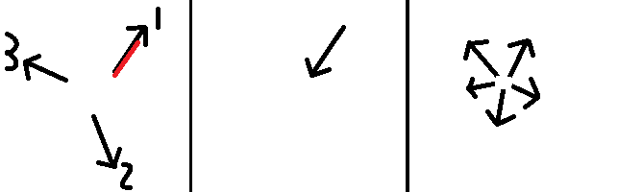

**HUD**

The game will have an incredibly minimal hud - 90% of the time there won’t be one at all. Any important information can be gathered from the natural visuals of the game. During combat this changes to show small orbs in the immediate vicinity of Oedipus. Using the mouse or joystick, you hover over one and see a small tooltip that hints at what selecting it will do. (See Telltale’s Walking Dead below)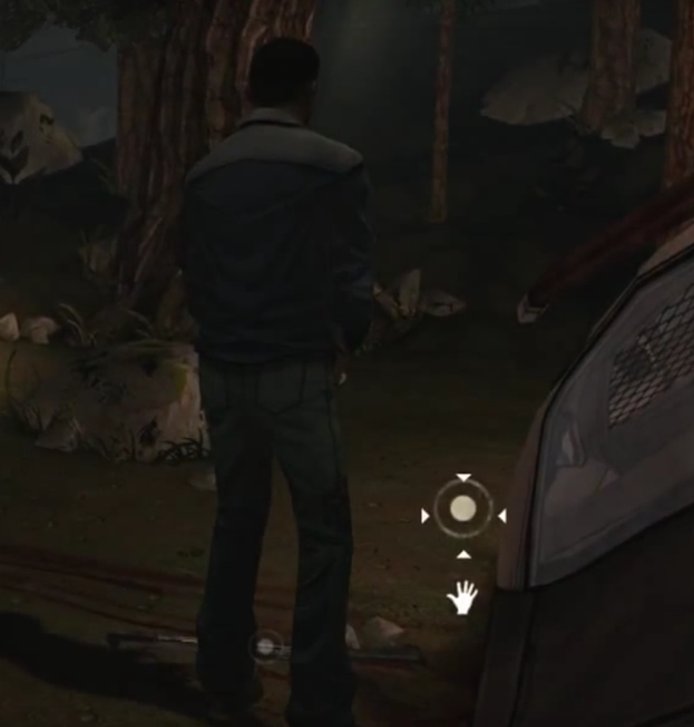

## Story World

**In One Line:** A series of mythological story lines (reminiscent of the past) which become progressively more dangerous (forcing combat to become more important)

**Overall Arena:** Greek Mythology - Greece from peace to wartime and suffering

**Value Oppositions and Visual Oppositions:**

Oedipus vs Hades

Value: Oedipus is absorbed by his past. Hades is absorbed by how others will see him, ie absorbed by the future.

Oedipus spends his time focusing on the past, with occasional flashbacks.

Throughout the game, cutscenes occur between levels where Hades’s trial is displayed. Here, we see Hades presenting a person that is not truly himself, and dwelling on the future.

Oedipus vs The Moirai

Value: Oedipus is absorbed by his past. Moirai are absorbed by their power.

Oedipus’s mythological world begins to lose its continuity as his visions of his past demons become more powerful. Illusion begins to rule it.

The Moirai’s world is cut and dry - all is known via their power. It is ruled by truth, and it is therefore bland.

## Key Emotional Moments

**Level 3 - Mycenae, *The Iliad* Part 1**

Helping Agamemnon sacrifice his Daughter. Hades involuntarily stopped Agamemnon from sacrificing his Daughter and therefore stopped the Greek army from heading to Troy to bring Helen back. You must find and console his daughter and guide her to her death, at the boat where her father waits. There you have the option of heading on the boat with them or staying on shore. The moment the deed is done, the harsh winds end.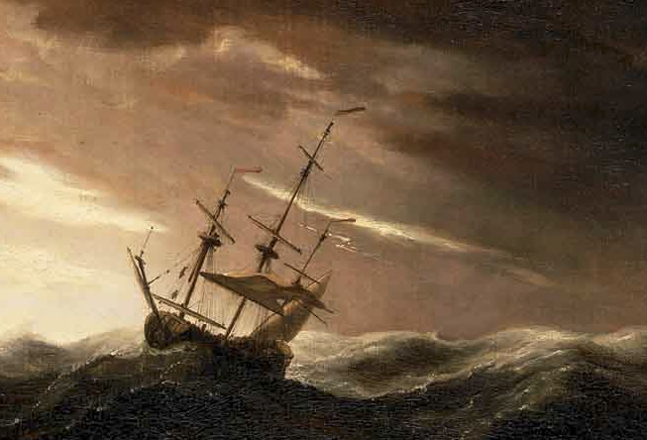

**Level 4 - Ithaca, *The Odyssey* Part 2**

When Odysseus returns to Ithaca, with the slaying of the Suitors. You must help them defeat the suitors and reclaim the land for the king. This begins as a regular combat, but as it goes on it gets more grim, but Oedipus is absorbed in it through his visions of his past demons. When it’s over, the remnants of the battle lay around, and Oedipus must tread through them to get to the next timeline.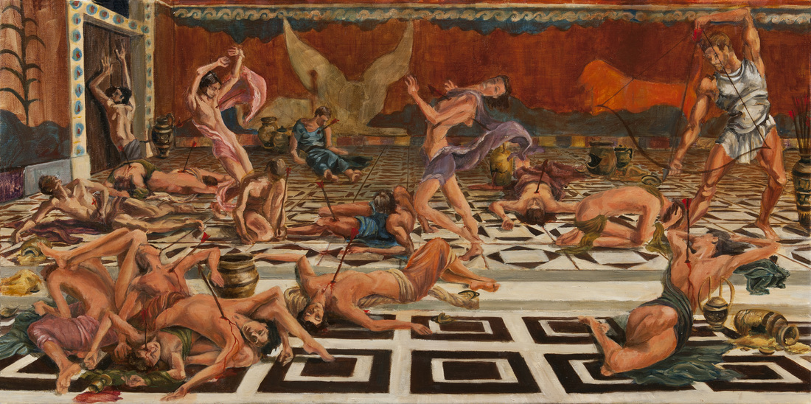

**Level 6 - Thebes, *Oedipus Tyrannus***

The second to last level is Oedipus’s own story. You end up on the mountain where Oedipus was left as a child, and are given the opportunity to kill yourself then and there, freeing yourself and all your loved ones from the pain you have caused. The player is able to attempt the killing, but Oedipus will stop himself at the last moment.



## Musical Supplements

**Led Zeppelin - Stairway to Heaven:** <https://www.youtube.com/watch?v=8pPvNqOb6RA>

A perfect song to accompany this game. The progression of the song from acoustic to hard rock mirrors the progression of Oedipus as he becomes younger and more plagued by his past demons. The process of reaching the Moirai can be seen as a literal stairway to heaven, with each storyline being the next stair. The lyrics also refer to changing your fate, which is very applicable:

*But in the long run*

*There's still time to change the road you're on*

I especially like this slower acoustic rendition: <https://www.youtube.com/watch?v=_2lI3vMxU84>

This version could play at the very beginning and very end of the game, while the original and its transition from acoustic to hard rock shows itself as the player progresses.

## Example Scene

The first scene following the introductory level takes place immediately after Oedipus travels through time for the first time, ending up in *The Odyssey*. This is the introduction of the character Telemachus, and he prys into who Oedipus is, turning the usual concept of probing NPC’s for background on its head, and showing that Telemachus doesn’t know how to follow convention.

The mechanics of Oedipus’s perceiving the present based on the past are also introduced. To do this, Oedipus is confronted with a moment exactly like the one where combat was introduced in the introductory level, with two animals charging him. Oedipus sees the two animals as wolves identical to the ones he had just fought, and the player is presented with models of wolves, but then halfway through Oedipus realizes that they are simply puppies, with their models changing to reflect this.

[View script here](http://drive.google.com/open?id=19rKl8exarkPnW1XeYwHSkPKe5_p0UNKXzzK-FVTwYSo)